INTRODUCING CIRCULARITY THROUGH CLIMATE-SMART AQUACULTURE IN BANGLADESH (Artemia4Bangladesh)

QUARTERLY PROGRESS REPORT

MARCH - JUNE 2020

Financed by: European Union

Project Implemented by: WorldFish

Disclaimer: The contents of this publication are the sole responsibility of Artemia4Bangladesh project implementation team. It can in no way be taken to reflect the views of the “European Union.”

Table of contents

List of Annexes ii
List of Acronyms iii
EXECUTIVE SUMMARY iv
1. INTRODUCTION 1
2. PROGRESS IN IMPLEMENTATION OF THE WORK PLAN 1
3. CHALLENGES, OPPORTUNITIES AND LESSONS LEARNED 3
4. CONCLUSION 4

List of Annexes

Annex 1: Artemia4Bangladesh introductory presentation 5
Annex 2: Meeting Minutes during April - May 2020 9
Annex 3: DeSiRA Web page information 16
Annex 4: Risk assessment due to COVID-19 20
Annex 5: Terms of Reference of international Artemia Expert 23
Annex 6: DoF letter of support to Artemia4Bangladesh 25
Annex 7: BFRI letter to collaborate with Artemia4Bangladesh 26
Annex 8: Fisheries resource information of Cox’sBazar district (Bangla version) 27
Annex 9: Fisheries resource information of Cox’s Bazar district (English version) 28
Annex 10: Revised work plan for the period of July to December 2020 29
Annex 11: Collaboration with DoF to set up Artemia Laboratory 32
Annex 12: Salt production report Cox’s Bazar (Bangla version) 33
Annex 13: Salt production report Cox’s Bazar (English version) 34
Annex 14: Opinion leaders in Cox’s Bazar district 35

List of Acronyms
BATiP Bangladesh Aquaculture Technology Innovation Platform
BFFEA Bangladesh Frozen Food Exporters Association
BFRI Bangladesh Fisheries Research Institute
BSCIC Bangladesh Small Cottage And Industries Corporation
BSFF Bangladesh Shrimp and Fish Foundation
COVID-19 Corona Virus Disease - 2019
DeSIRA Development Smart Innovation Through Research In Agriculture
DoF Department of Fisheries
EC European Commission
EU European Union
EUD European Union Delegation
MOFL Ministry of Fisheries and Livestock
NGO Non-Government Organization
SHAB Shrimp Hatchery Association of Bangladesh

EXECUTIVE SUMMARY
Cox’s Bazar district plays a significant role in Bangladesh economy through production of crude salt, aquaculture, fisheries and tourism. The low productivity of coastal aquaculture, low profitability in salt production, climate induced risk and influx of rohingya refugees increases the vulnerability of the population in the area. The aims of the Artemia4Bangladesh project report are to describe the progress of the project activities, challenges faced and lessons learned during March-June 2020.
The major achievements during this period include (i) dissemination of project information to major stakeholders such as Department of Fisheries, Bangladesh Fisheries Research Institute, Bangladesh Small Cottage and Industries Corporation, Non-Government Organizations, private companies, (ii) participation in progress review meetings, (iii) shortlisting the candidates interested in different positions of the project, (iv) risk assessment in program implementation and financial implication due to Corona Virus Disease - 2019 (COVID-19), (v) recruitment of international Artemia expert, (v) initiation of the collaboration with major stakeholders, (vi) gather information on aquaculture, fisheries and salt production of the project area, (vii) progress in preparation of training and extension materials, (viii) identification of opinion leaders for implementation of the activities, and (ix) revision of the work plan for July - December, 2020.
Integrated Artemia and salt production is a key activity of the project. Salt production in Cox’s Bazar is a seasonal activity between December to May. Delayed grant contract signed in March 2020 and COVID-19 pandemic hampered the implementation of project activities in the salt production season. Moreover, the project was partially suspended from 10 May to 9 August 2020.
The future plan is to accelerate the project activity for the remaining period of the year, increase stakeholders engagement, enhance virtual communication in program implementation considering safety regulation under COVID-19.

1. INTRODUCTION
European Union (EU) grant through Development Smart Innovation through Research in Agriculture (DeSIRA) was confirmed for Artemia4Bangladesh on 6 March 2020. The overall goal of the project is to enhance food and nutrition security in Bangladesh through climate smart innovations. The specific objectives are to (i) introduce an integrated salt and Artemia production system and (ii) increase marine aquaculture productivity and production in the salt farms in Cox's Bazar district.
The project planned activities during this period were to set up a local office in Cox’s Bazar, recruitment of project staffs, organize stakeholder consultation meeting/ training, develop collaboration with national stakeholders, conduct baseline survey, initiate collaborative research with European, South East Asian and Bangladeshi Universities, identify opinion leaders in the project area, selection and set up demonstration farms, capacity building training of trainers, set up Artemia laboratory for quality control, Artemia cyst and biomass processing and packaging, training of extension agents and local service providers.
In the beginning, the grant confirmation was delayed than expected. Furthermore, COVID-19 was first detected in Bangladesh (https://www.iedcr.gov.bd/) on 8 March 2020. The pandemic quickly spread across the country including Cox’s Bazar. The objectives of this report are to describe the progress of the project activities, challenges faced and lessons learned during March-June 2020.

2. PROGRESS IN IMPLEMENTATION OF THE WORK PLAN
Table 1: Artemia4Bangladesh list of activities with progress till now
List of planned activities | Progress till now
General activities
Artemia4Bangladesh introductory presentation | A presentation prepared including basic information of the project. The presentation distributed to the Department of Fisheries (DoF), Ministry of Fisheries and Livestock (MOFL), Government of Bangladesh, EU Delegation (EUD) office in Dhaka (annex 1).
Progress review meetings | Participated in virtual progress review meetings together with EUD office and WorldFish Country Director held in April and May 2020. Meeting minutes and progress reports submitted to EUD office (annex 2).
DeSIRA webpage information | A document prepared for DeSIRA webpage including information on project objectives, background, theory of change to achieve the objectives, impact pathways, main activities, work packages, domestic and international stakeholders. The document was submitted to EUD Office, Dhaka (annex 3).
Recruitment of project staff | The position advertised in bdjobs, candidates were shortlisted.
Risk assessment due to COVID-19 | A report on risk assessment for program implementation and financial implication due to COVID-19 was prepared (annex 4).
Recruitment of International Artemia Expert | The terms of reference (annex 5) of international Artemia expert was prepared, advertised in WorldFish website, contract prepared and recruitment finalized.
Collaboration with national stakeholders | Government institutions including DoF (annex 6), Bangladesh Fisheries Research Institute (BFRI) (annex 7), Bangladesh Small Cottage and Industries Corporation (BSCIC); Non-Government Organizations (NGO) including Coast Trust, Prottyashi, Shushilan; private companies Modern Hatchery Limited, Golden Aquaculture Shrimp Hatchery Limited, Fish Tech (BD) Limited, Irwan Trading Limited expressed interest to collaborate with the project activities.
Research in collaboration | Priority research areas were identified through guidance of Artemia expert, listed in annex 2.
Training and extension material development | Draft a booklet “Guidelines For Artemia Production In Artisanal Solar Salt Farms in Cox’s Bazar, Bangladesh” and sent to Artemia expert for review.
Gather fisheries resource information of Cox’s Bazar district | The fisheries resource information were collected from DoF Cox’s Bazar office (annex 8 and 9).
Revised work plan July - December 2020 | Revised work plan for July - December 2020 (annex 10).
Expected result 1.1 : Artemia cyst and salt integrated production system proven feasible
Set up Artemia Laboratory | Department of Fisheries expressed interest in the collaboration to set up an Artemia laboratory (annex 11).
Gather salt production and price information | In 2020, on an average crude salt price was at least 30% less than last year. The salt price was further dropped due to COVID-19. This caused reduced income and profitability of salt farmers (Source: personal communication to salt farmers and BSCIC Cox’s Bazar). One week salt production and price information showed in annex 12 and 13.
Identify opinion leaders | Prepared a primary list of opinion leaders of the project area (annex 14).
Expected result 1.2 Artemia cyst and salt integrated production system effectively established and widespread among the salt farmers.
Facilitate/ collaboration with financial/ microcredit institutions for access to credit for Artemia cyst and biomass production | Three NGOs were identified namely Coast Trust, Prottyashi, Shushilan have microcredit programme with salt farmers in Cox’s Bazar district. The NGOs expressed interest to participate in the programme.
Expected result 2.2 Increased revenue of salt farmers due to adoption of a second profitable activity (aquaculture).
Facilitate/ collaboration with financial/ microcredit institutions for access to credit for integration with aquaculture | Three NGOs named earlier have ongoing programme on aquaculture in Cox’s Bazar district. The NGOs expressed interest to join in integrated salt-aquaculture activities.
Expected result 2.3 Enhanced saline tolerant species seed production due to adoption of improved technologies
Evaluate the support of hatcheries for crablet production | Two crab hatcheries in Cox’s Bazar requested for (i) technical assistance through expert to improve efficiency in crablet production, (ii) training farmers on crab farming and soft shell crab production using hatchery produced crablets.

3. CHALLENGES, OPPORTUNITIES AND LESSONS LEARNED
Challenges:
- COVID-19 pandemic related death was first reported in Bangladesh on 18 March 2020. Total number of confirmed cases in Bangladesh reached more than 145,000 till 30 June 2020 (Ministry of Health and Family Welfare, Government of Bangladesh, https://dghs.gov.bd/index.php/en/component/content/article?id=5393). More than, 3000 COVID-19 infections has been confirmed in Cox’s Bazar district. Bangladesh has been following movement restrictions since 26 March 2020 as a precautionary measure and safety procedure. Report on the risk assessment in program implementation due to COVID-19 was prepared in April and shared with EUD office (annex 3). In consultation with EUD, WorldFish requested for a partial suspension of the project activities. The EUD accepted the partial suspension of the project activities effective from 10 May to 9 August 2020 including budget for the period.
- Artemia production in solar salt farms is a new technology in Bangladesh. Implementation of activities, dissemination of information and stakeholders engagement for a new technology is difficult; considering field visits, direct contact with the stakeholders, consultation meeting, and hands on training have been inhibited under COVID-19 context.
Opportunities:
- Global COVID-19 pandemic showed the necessity of virtual communication in project implementation. This increased the importance of digital platforms (for example MEL platform, Facebook page) in routine project activities.
- Collaboration, coordination with WorldFish led projects active in Cox’s Bazar district such as USAID funded Bangladesh Aquaculture and Nutrition Activity, EcoFish-BD will be useful to improve efficacy in programme implementation.
Lessons learned:
- Regular communication with various stakeholders such as DoF, BFRI, BSCIC, NGOs, private companies, farmers, hatchery operators are essential for project design, information gathering and implementation of activities. This increased the capacity to work under difficult situation such as COVID-19 pandemic.

4. CONCLUSION
The project implementation have been affected due to delay in grant confirmation and first COVID-19 report in March. This caused inability to set up an office in Cox’s Bazar, delay in recruitment of project staff, launching project inception meeting, conduct baseline survey, selection of demonstration sites, training of extension agents, local service providers and organize visits. Under these circumstances, EUD approved a partial suspension request of WorldFish from 10 May to 9 August 2020. The activities performed during the period were preparation of introductory presentation, DeSIRA webpage information, recruitment of Artemia expert, collaboration with national stakeholders, gather fisheries resource information of the project area, identification of opinion leaders, selection of the research titles, progress to prepare guidelines for Artemia production in the solar salt farms and revised workplan for the remaining period of the year. In the future more emphasis will be provided on virtual communication in implementation of project activities considering safety regulation under COVID-19 pandemic.

Annex 1: Artemia4Bangladesh introductory presentation

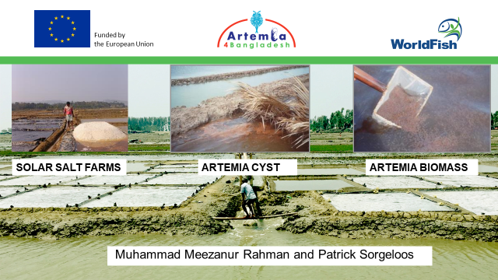 | 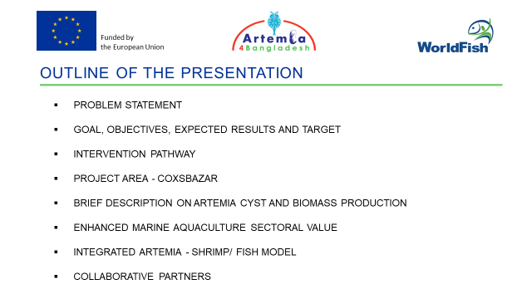
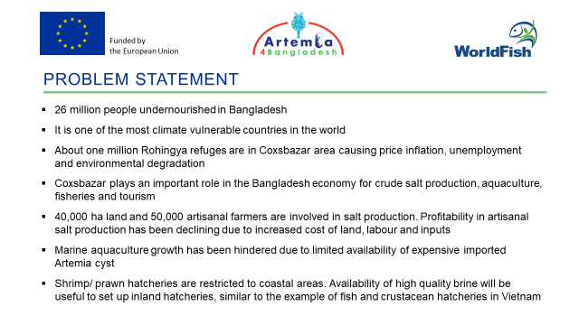 | 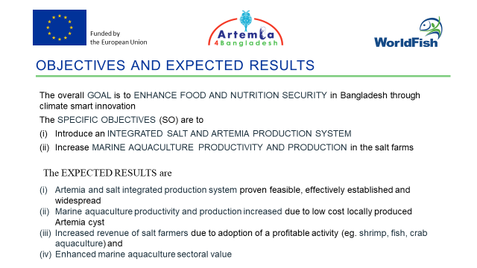
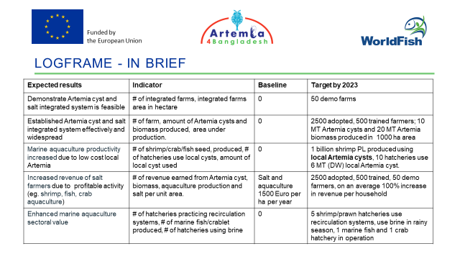 | 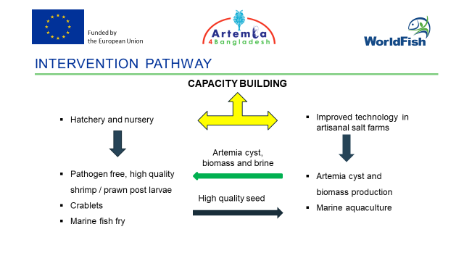
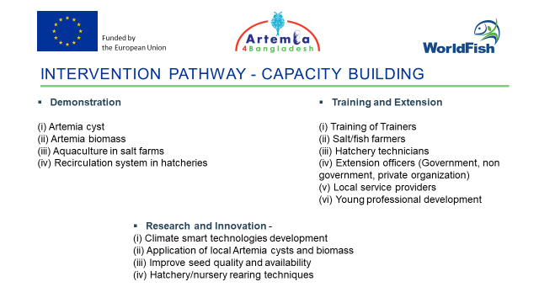 | 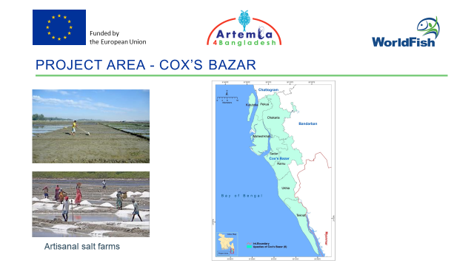

Annex 1 continued
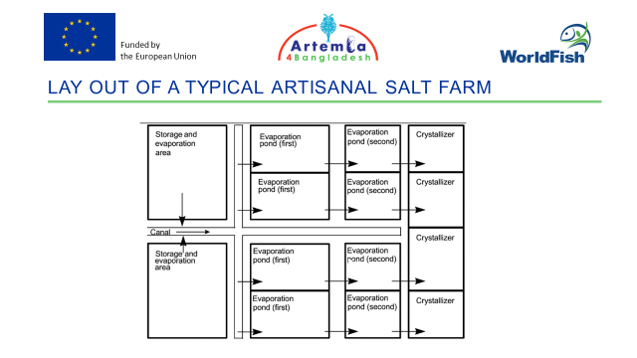 | 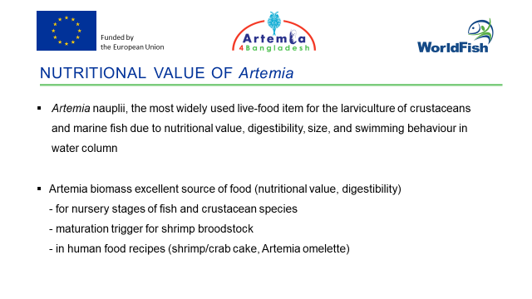
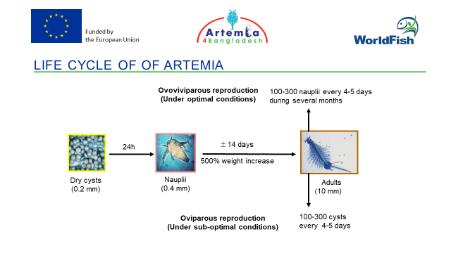 | 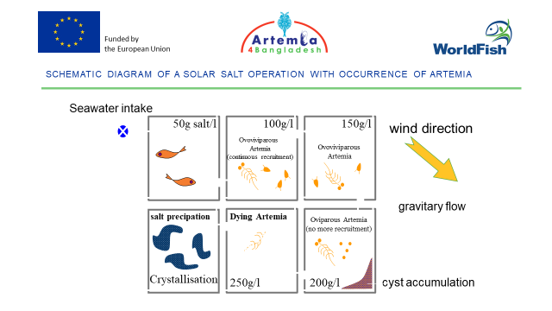
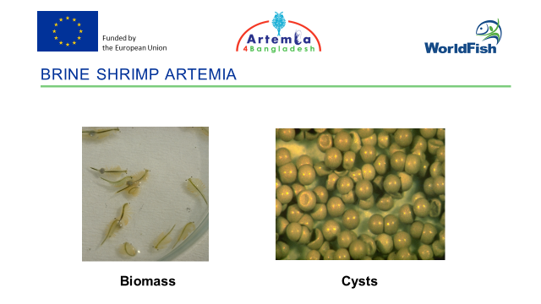 | 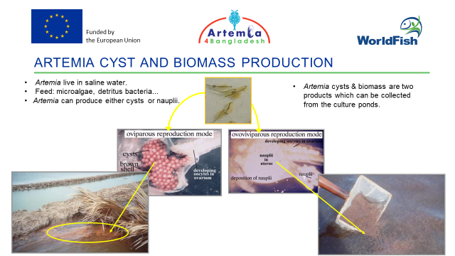
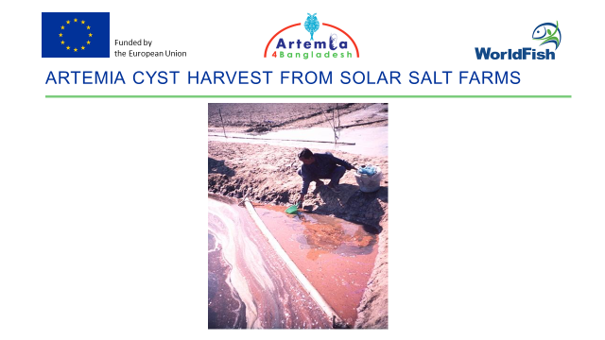 | 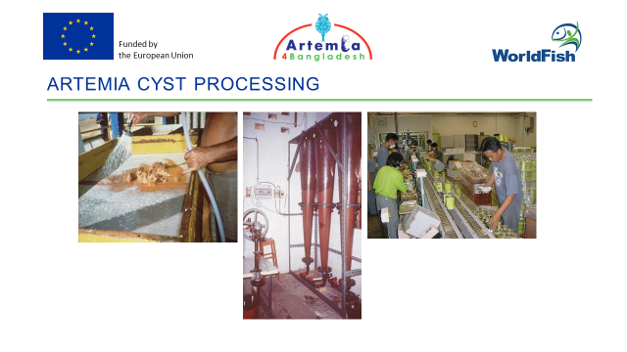

Annex 1 continued
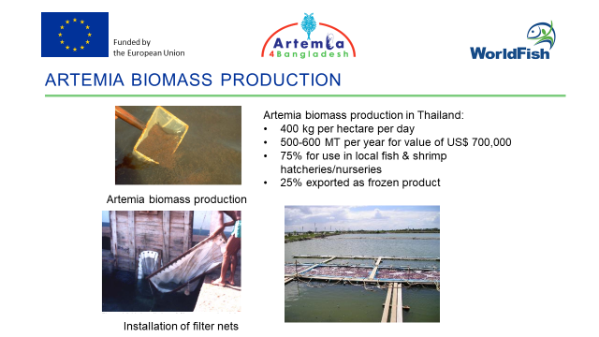 | 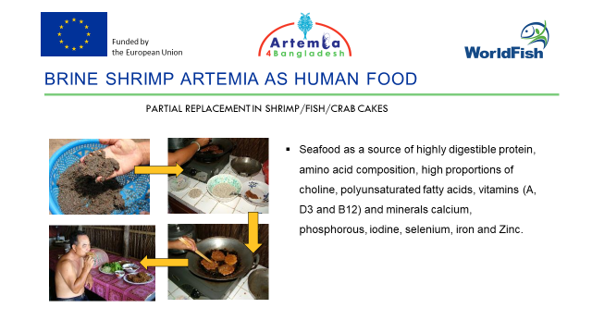
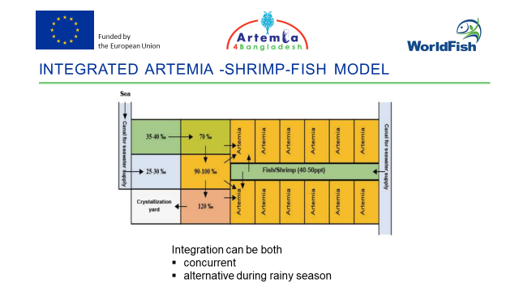 | 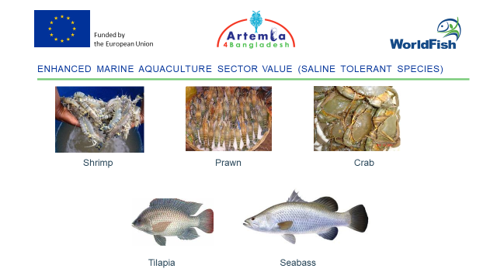
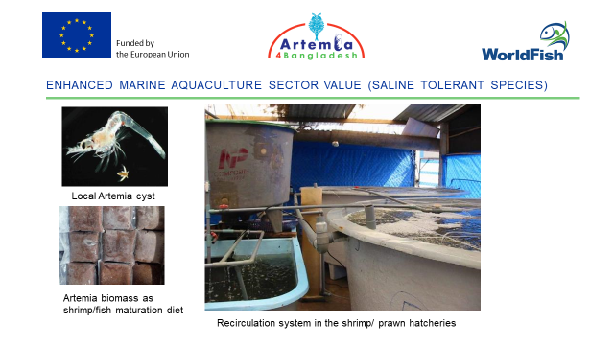 | 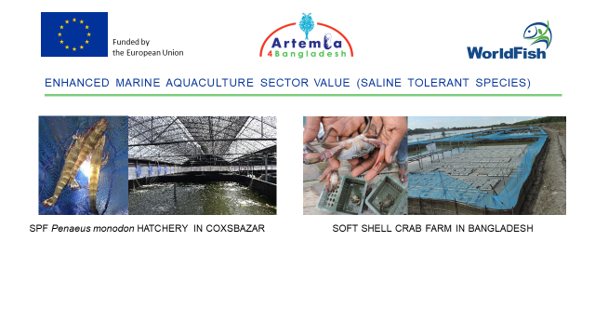
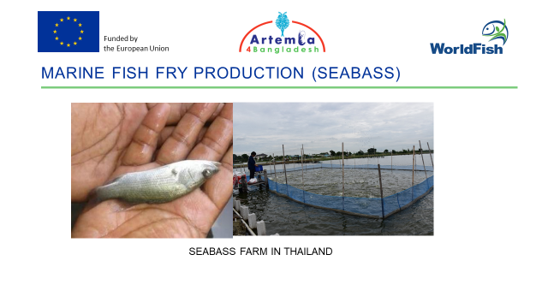 | 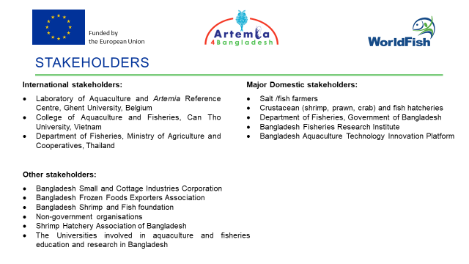

Annex 1 continued

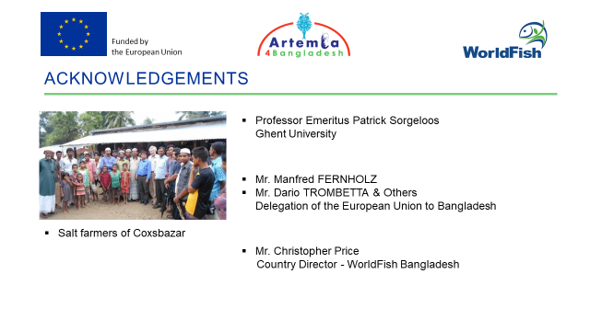 | 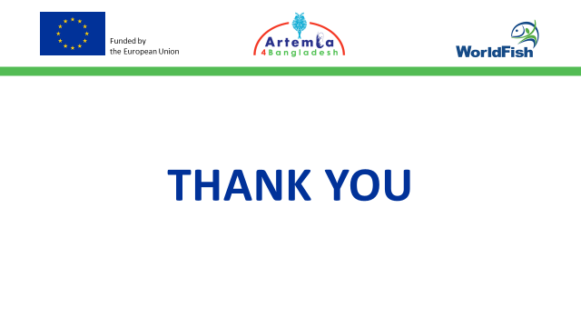

Annex 2: Meeting Minutes during April - May 2020

MINUTES OF THE FIRST PROGRESS REVIEW MEETING
Date: 8 April 2020
The meeting was held virtually through Zoom at 12.00-13.00 hours Bangladesh time.
The participants of the meeting were:
- Mr. Dario TROMBETTA
- Mr. Manfred FERNHOLZ
- Mr. Meezanur Rahman
- Mr. Christopher Price (joined from UK)

Welcome by Dario:
Mr. Dario organized and initiated the meeting. The participants briefly discussed COVID-19 pandemic; the lock down as a preventive measure; and expressed concern about impact on economy, agriculture, and aquaculture. Manfred pointed out the global crisis might be followed by an economic crisis. Dario mentioned that the WorldFish report on the impact of COVID-19 in the implementation of Artemia4Bangladesh project had been well received. He asked Meezan to present the progress report.
Meezanur Rahman:
The presentation covered a problem statement and progress to date; a proposed work plan for the period of March to June 2020; and a summary report on the COVID-19 impact and plans to mitigate. The key points of the presentation were that:
- Contract signing had been delayed.
- A Country wide stay home order of Bangladesh government had been in place since 26th March due to COVID-19.
- There had been a delay in implementation of project activities.
- The work plan, activity matrix and expenses needed to be revised to cope with post lock down.
- Project expenses would potentially dropping by at least by 50% of proposed plan during March-June 2020.
- Terms of reference for staff recruitment had been finalized and WorldFish will advertise the positions soon through online portals. A plan to recruit key staff in May/June to work at a limited scale and recruitment of the remaining position would be prepared.
- The “International Artemia Expert” consultant position had been advertised.

Annex 2 continued
- Draft of the letters had been prepared for collaboration between Artemia4Bangladesh and national major stakeholders including Department of Fisheries (DoF), Bangladesh Fisheries Research Institute (BFRI) and Bangladesh Small Cottage Industries Corporation (BSCIC).
- Work was being prioritized during the ‘stay home’ period e.g. database development, development of training and extension materials and virtual calls with stakeholders.
- Work with the International Artemia Expert would be through digital communication.

Mr. Dario recommended to -
- Continue in improving knowledge of the sector
- Strengthen cooperation with Ministry of Fisheries and Livestock (MoFL) of Government of Bangladesh
- Liaison with appropriate projects and organizations active in Cox’s Bazar district
- Unbiased selection of the beneficiaries
- Properly structure the project
- Prepare communication messages
- Continue risk assessment and reassess the situation
- Proceed with the recruitment process
Mr. Manfred thanked Chris and Meezan for the report and PowerPoint presentation. He remarks that the crisis due to COVID-19 and lockdown might extended till May 2020. He asked WorldFish to decide for two months suspension of the project considering lockdown period. WF may request for automatic extension at the end of the project in lieu of this suspension period. He emphasized for the project team and logistics support to be ready by August 2020 and recruitment of staff in consideration of the value for money.
Mr. Chris pointed out the relationship of the staff working time and salary with the suspension period. He will follow up with WorldFish Head Quarter to decide about the possibility of suspension for two months.
Mr. Dario closed the meeting and proposed to organize progress meeting periodically.

Annex 2 continued
MINUTES OF THE SECOND PROGRESS REVIEW MEETING
Date: 21 April 2020
The meeting was held virtually through Zoom at 16.00-16.45 hours Bangladesh time.
The participants of the meeting were:
- Mr. Dario TROMBETTA
- Mr. Manfred FERNHOLZ
- Mr. Meezanur Rahman
- Mr. Christopher Price (joined from UK)

Welcome by Dario:
Mr. Dario organized and initiated the meeting. Dario asked Meezan to present progress.
Meezanur Rahman:
The agenda of the meeting was agreed:
- Progress since first progress review meeting on 8th April 2020 (Meezan, Chris)
- Discuss a potential suspension.
- Detailed outline of activities during next period (Meezan, Chris)
The presentation covered the points 1 and 3. The second point was discussed after the presentation.
The key points of the presentation were:
- Communication with stakeholders including: (i) letters sent to national institutions and telephone follow up with the office of - Director General of Department of Fisheries (DoF), Director General of Bangladesh Fisheries Research Institutes (BFRI), and Chairman of Bangladesh Small Cottage Industries and Corporation (BSCIC); (ii) virtual communication with shrimp hatcheries in Cox’s Bazar specifically Fish Tech hatchery, Golden Aqua Shrimp hatchery, MKA hatchery and Modern hatchery.
- National staff positions have been advertised in WorldFish websites and BDJobs (https://www.bdjobs.com/). The position for the International Artemia Expert position has been advertised in WorldFish website.
- Preparation of a booklet “Artemia production in ponds” is ongoing. The booklet will be edited by Artemia expert and will be used as a basis of communication messages and training materials for the project.
- The plan for fourth coming weeks is to:
  - Communicate with non-government organizations engaged with salt farmers in Cox’s Bazar namely Sushilan (https://shushilan.org/), Coast Trust (http://coastbd.net/), Prottyshi (http://www.prottyashi.org/).
Annex 2 continued
  - Draft booklets on Artemia production and aquaculture in salt farms.
  - Draft communication materials.
Mr. Dario initiated the discussion on the second point of the agenda. He proposed that:
a WorldFish consider a partial suspension of the project due to the government lockdown
because of COVID-19.
  - WorldFish consider the timeframe for the suspension.
  - WorldFish propose what costs need to be covered during suspension to ensure that all work does not stop and that we put ourselves in a position to re-engage fully when practical and safe.
It was agreed that WorldFish would propose an extension to the European Delegation (with workplan and budget) and that this could then potentially be agreed by both parties.
It was also agreed that a virtual progress meeting be held every three weeks instead of two weeks.
Mr. Manfred suggested that WorldFish could consider requesting a three month suspension for the period of May -July 2020 but that it would be effective after the approval of suspension note by the Delegation. He emphasized that an extension of the project in lieu of this period would be considered.
Mr. Chris agreed that WorldFish would prepare a request for suspension.
Mr. Dario closed the meeting.

Annex 2 continued
MINUTES OF THE THRID PROGRESS REVIEW MEETING
Date: 13 May 2020
The meeting was held virtually through Zoom at 16.00-16.35 hours Bangladesh time.
The participants of the meeting were:
- Mr. Dario TROMBETTA
- Mr. Manfred FERNHOLZ
- Mr. Meezanur Rahman
- Mr. Christopher Price (joined from UK)

Welcome by Dario:
Mr. Dario organized and initiated the meeting. In the beginning of the meeting, Mr. Dario confirmed the approval of project suspension for 90 days effective from 10 May 2020 until 09 August 2020. He asked for any comments from WorldFish about the project suspension. Mr. Chris agrees with the suspension period and the condition. Mr. Dario proposed the interval of progress review meeting every three to four weeks. Mr. Chris agrees with the interval of progress review meeting. Mr. Dario asked Meezan to present progress.

Meezanur Rahman:
The presentation include advancement from the second progress review meeting and future plan.
- ADVANCEMENT FROM THE SECOND PROGRESS REVIEW MEETING
i. Partnership and collaboration with government, non-government, private and international organizations
- Director General (DG) of DoF - is likely to instruct DoF officials in Cox’s Bazar district to cooperate with Artemia4Bangladesh through a letter after lock down period.
- DG of BFRI - formally replied to Country Director of WorldFish expressing interest for the collaboration with the project.
- Chairman of BSCIC assigned General Manager Mr. Golam Rabbani to follow up with WorldFish for the collaboration.
- Virtual communication with shrimp hatcheries in Cox’s Bazar; MKA Hatchery (https://www.mkahatchery.com/), Modern Hatchery (https://bsmgroupbd.com/), Fish Tech Hatchery (http://www.fishtechbd.net/), and Golden Aquaculture Shrimp hatchery.
- Modern hatchery could be a potential partner for Artemia production in the salt farms, application of locally produced Artemia in the hatchery and pathogen free shrimp post larvae supply in salt farms.

Annex 2 continued

- Two crab hatchery located in Cox’s Bazar claimed success in crablet production in a limited scale, one operated by DoF and the other in private sector.
- Three non-government organizations namely Sushilan (https://shushilan.org/), Coast Trust (http://coastbd.net/) and Prottyshi (http://www.prottyashi.org/) provided the list of beneficiaries those are salt farmers.
- Initiative taken to formulate International Artemia consortium through coordination of Artemia expert. The consortium will be useful for cooperation in research and innovation, capacity building through training and exchange visits.

ii. Recruitment of staff
Advertisement for the positions including junior research assistant, portfolio assistant, research assistants, research associate, training associate, monitoring and evaluation officer are closed. The recruitment procedure of International Artemia expert is finalized.

iii. Develop training and extension materials
Prepared the first draft on “GUIDELINES FOR ARTEMIA PRODUCTION IN ARTISANAL SOLAR SALT FARMS IN COX’S BAZAR, BANGLADESH” by Muhammad Meezanur Rahman, Nguyen Van Hoa, and Patrick Sorgeloos and submitted to Artemia expert for review.
iv. Artemia expert prepared a list of potential research titles. National universities will be identified to implement the research through partnership. The list of research titles include -

- Selection/comparison of suitable “agricultural waste” products as fertilizer and or food for Artemia production.
- Selection/comparison of appropriate Artemia strains for cyst and biomass production for different applications in aquaculture for example marine and freshwater, fish and crustaceans.
- Feasibility of Artemia biomass for human consumption in Bangladesh through preparation of fish sauce (as practiced in Thailand), ingredient in fish/shrimp/crab cake and Artemia omelet (as practiced in Vietnam).
- Cost benefits analysis of integrated salt and Artemia production considering reduction of salt production, improve salt quality and effect of water depth.
- Feasibility of Artemia biomass production in the salt farms during the rainy season (as practiced in Thailand).
- Integration of different aquaculture practices in the salt ponds during the rainy season (traditional methods, shrimp, prawn, crab, Tilapia and marine fish production).
- Cost benefits analysis of the application of locally produced Artemia cysts in aquaculture; for examples hatcheries of marine and freshwater fish species, crustacean species.
- Use of Artemia biomass in aquaculture for example maturation and nursery diet of fish/ crustacean species. Different product qualities and different processing/transportation methods of Artemia biomass.
- Use of local Artemia for the improvement of mud crab larviculture.
- Quality evaluation of Artemia produced in Bangladesh with world standards.
- Socio-economics benefits of integrated salt, Artemia and aquaculture.

Annex 2 continued

- Optimal storage conditions of Artemia cysts in concentrated sea water compared to cyst drying.

- FUTURE PLAN

Plan to work in forthcoming weeks covers:

- Continue to develop training and extension materials including manual for Artemia production and aquaculture in salt farms
- Prepare detailed research proposals including justification, analysis plan, timing, collaboration.
- Discuss the plan with DoF to set up Artemia laboratory in Cox’s Bazar
- Progress the collaboration with NGOs and international stakeholders

Furthermore, the list of communication items plan to develop in Artemia4Bangladesh are -
Item
Web page | Facebook page, research gate, MEL platform of WorldFish, Linkedin
Communication materials | Leaflet/ flyers, posters, fact sheets, file folders, pen drive
Media campaign | Video (youtube), animation, TV broadcasting, printed media
Visibility materials | Umbrella, T-shirts, Caps, Souvenir/ crest, Bags (jute/cloth), sticker message
Event organization/ participation | National fish week each year

Mr. Dario suggested to revise the workplan after the suspension period. He commented that the communication materials in social media to address large scale audience with general information and printed materials with specific audience covering technical information. He discouraged investment in umbrella, T-Shirts, caps to minimize the expenses. Mr. Chris agrees to minimize investment in those items.
Both Mr. Dario and Mr. Manfred appreciated the logo of Artemia4Bangladesh. Mr. Dario asked Meezan for a brief study on the impact of COVID-19 in project area and present in the next meeting.
Mr. Dario closed the meeting.

Annex 3: DeSiRA Web page information
Artemia4Bangladesh: Introducing Circularity Through Climate-Smart Aquaculture in Bangladesh

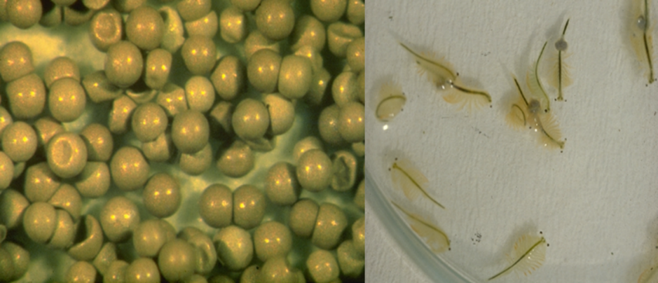
Figure 1. Artemia cysts (left) and biomass (right)
Objectives of the project:
The overall objective is to enhance food and nutrition security in Bangladesh through climate smart innovation. The specific objectives are to: (i) introduce an integrated salt and Artemia production system - not yet explored in Bangladesh; and subsequently, (ii) increase marine aquaculture production and productivity.

Background:
Bangladesh is one of the most densely populated and climate vulnerable countries in the world, while the Cox’s Bazar district is one of the least developed and most vulnerable regions of the country. The district historically plays a significant role in crude salt production, aquaculture, fisheries and tourism. 95% of the 1.7 million metric tons of crude salt produced each year, about 10% of the shrimp aquaculture and 80% of the shrimp post larvae produced in Bangladesh is coming from Cox’s Bazar. The salt industry engages some 50,000 artisanal salt farmers and provides livelihoods to approximately 1.5 million people in Cox’s Bazar. Currently, salt farmers have not explored the possibility of integrated production with Artemia (a branchiopod) and aquaculture. The low productivity of coastal aquaculture and the climate induced risks lead to low profitability, and limited options for livelihood improvement.
Artemia cysts and biomass (Figure 1) is mainly used worldwide as larval diet of shrimp and marine fish, and is necessary to increase the value of aquaculture. Many countries have adopted new technologies to integrate Artemia and aquaculture production to improve the profitability of salt farms, while Bangladesh is still fully dependent on import. Moreover, Bangladeshi salt farmers are unaware of the potential of integrated Artemia, salt and aquaculture production.

Annex3 continued
The theory of change to achieve the objectives:
The project aim is to increase food and nutrition security of salt/fish farmers’ households. The expected outcome is the increased integrated production of salt, aquaculture and Artemia taking into account that climate induced hazards such as prolonged cold winters, high temperatures are potential risks. The strategy is to carry out participatory research to produce (i) improved knowledge on Artemia production, processing and preservation; as well as (ii) improved technologies to ensure Artemia and salt integrated production systems are effectively and widely adopted. The project will ensure stakeholders engagement in decision making (for example, operation and management of demonstration farms) in implementation through demonstration farms to develop integrated salt, Artemia and aquaculture models.
Capacity building of domestic stakeholders (for example extension workers, young professionals) and facilitating linkages and networks among domestic and international stakeholders will increase access and availability of information and technologies to the salt farmers and shrimp/fish hatcheries. Laboratories will be established for quality assurance of the Artemia. Project information will be actively disseminated using print and electronic media. Identification of policy/regulatory issues and policy recommendations will be formulated through interaction with policy makers for sustainable integrated Artemia production system. Successful models of integrated production system, stakeholders engagement, knowledge sharing workshops will promote and facilitate the scaling-up of the project findings.
This will decrease marine aquaculture production costs due to locally produced Artemia and increase the revenue of salt farmers. An impact pathway has been shown in figure 1.
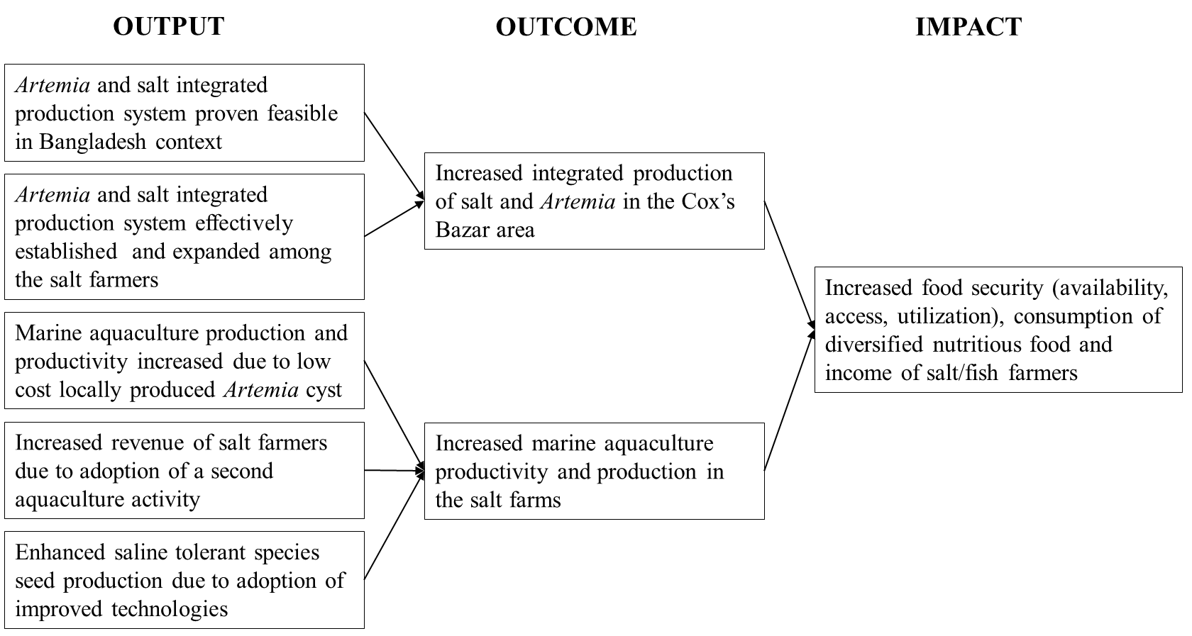

Figure 2: Artemia4Bangladesh Impact pathway
Annex 3 continued
Main activities:
The major activities include: (i) surveys to determine the current socio-economic status of salt farmers; (ii) selection and set up of integrated salt-Artemia and aquaculture demonstration farms; (iii) promote technologies for Artemia production, processing and preservation; (iv) establishment of laboratory facilities for Artemia and aquaculture; (v) implementation of good aquaculture practice of saline tolerant species (e.g. shrimp, crab) through demonstration and training; (vi) identification of climate sensitive management decisions to reduce risks (e.g. high/low temperatures, out of season rainfall) in Artemia and aquaculture production; and (vii) monitoring, evaluating and disseminating of the project findings.
Stakeholders will be involved in needs assessment, setting project priorities, preparation of work-plans and dissemination of findings to promote transparency and increase ownership in project activities.
Capacity building through training, workshops/ seminars will cover (i) production, processing and preservation of Artemia; (ii) correct application of locally produced Artemia in aquaculture; (iii) introduction and improvement of technologies for the production of saline tolerant aquaculture species and halophytes (saline tolerant plants).
Organization:
WorldFish will be the lead agency. A Program Steering Committee, including representatives from the European Union Delegation office, WorldFish, partners and farmer representatives will ensure multi stakeholder approach in project implementation.
The work packages and allocated budget have shown in the table below:
Work packages | Budget (in Thousand Euro)
Project management, collaboration with partners and stakeholders | 293
overview of crude salt production system, scope of integration with Artemia and aquaculture | 150
Identification of demonstration farms | 130
Testing the feasibility, adoption and dissemination of Artemia and aquaculture production systems | 983
Increasing marine aquaculture production and productivity through improvement of seed and production technologies | 493
Cross cutting themes covering climate smart management and gender | 125
Monitoring pathways to impact | 326

Annex 3 continued
Implementing organizations:
- WorldFish (International Centre for Living Aquatic Resources Management)

Stakeholders of the project:
Major International stakeholders:
- Laboratory of Aquaculture and Artemia Reference Centre, Ghent University, Belgium
- College of Aquaculture and Fisheries, Can Tho University, Vietnam
- Department of Fisheries, Ministry of Agriculture and Cooperatives, Thailand
Major Domestic stakeholders:
- Salt /fish farmers
- Crustacean (shrimp, prawn, crab) and fish hatcheries
- Department of Fisheries, Government of Bangladesh
- Bangladesh Fisheries Research Institute
- Bangladesh Aquaculture Technology Innovation Platform

Other stakeholders:
- Bangladesh Small and Cottage Industries Corporation
- Bangladesh Frozen Foods Exporters Association
- Bangladesh Shrimp and Fish foundation
- Non-government organisations
- Shrimp Hatchery Association of Bangladesh
- The Universities involved in aquaculture and fisheries education and research in Bangladesh

Localisation: Cox’s Bazar, Bangladesh
Funding and co-funding: European Commission
Duration: 48 months




Annex 4: Risk assessment due to COVID-19

RISK ASSESMENT DUE TO COVID-19
COVID-19 was first identified in Wuhan, China in 2019. On 11 March 2020 World Health Organization (WHO) declared the disease as a pandemic. As of 29 March 2020, the disease has spread to nearly 200 countries, causing infection of approximately 600,000 and deaths of about 27,000 people in the world (WHO, 2020). In Bangladesh, the disease was first reported on 7 March 2020 (IEDCR, 2020). As a precautionary measure, the Government of Bangladesh announced a countrywide lockdown from the 26th March to 4th April 2020. The number of infected people in this country is increasing. It is still difficult to predict the future situation in Bangladesh.
The European Commission (EC) and WorldFish signed an agreement to implement the “Artemia4Bangladesh” project effective from the 6th March 2020. COVID 19 has affected and will delay implementation of the inception of the project. A technical risk assessment and mitigation plan is presented in Table 1. The anticipated financial implications and mitigation measures presented in Table 2.
Table 1: Risk, assessment and proposed mitigation for COVID-19 to implement Artemia4Bangladesh activities in April / May 2020.
Serial number | Risk | Assessment | Mitigation measures
1 | Inability to establish an office in Cox’s Bazar | High | Using existing staff in Cox’s Bazar WF will try and establish an office. If this is not possible we will need to wait until lockdown is lifted to travel to Cox’s Bazar and identify the options for an office.
2 | Delay in recruitment of project staff | Low | WF will advertise for all positions through BDJobs and other portals. WF will shortlist candidates and consider online interviews.
3 | Delay in contracting project staff | High | Consideration will be made to what staff are essential staff to start the project. It is not envisaged many staff will actually be contracted until there is clarity on how long the pandemic might last and how long GoB restrictions will be in place. In the interim, as the pace on other WF programmes has slowed, existing finance and administration staff can be co-opted to provide cover.
4 | Delay in launching the programme in Cox’s Bazaar | Medium | Electronic materials will be produced that can be distributed through WF existing programmes. Materials can be distributed to all WF partners and collaborators (Department of Fisheries, Bangladesh Shrimp and Fish Foundation etc:).
5 | Delay in holding project inception meeting | Low | This meeting can be held electronically at a time to suit all parties. The preparation of the electronic materials will continue.
6 | Delay in recruitment of International Artemia Expert and activities anticipated | Medium | The Terms of Reference has been prepared. The position has been advertised in (https://www.worldfishcenter.org/career-opportunities).  WF will finalize the recruitment in April. The field visit of Artemia Expert will be delayed and the opportunity to undertake some work through digital communication will be explored. Development of training material and some stakeholder consultation will be undertaken. The original contract will be split to reflect the delay in field activities.
7 | Delay in the implementation of a baseline survey | High | The questionnaire can be drafted. Advertisement for app and database development will proceed. Thought will be given to what can be undertaken through telephone interviews, literature review etc: The sample frame, field-testing and survey will be delayed.
8 | Delay in collaboration with national and international partners | Medium | To the extent possible, consultations will proceed through electronic communication.
9 | Delay to identify opinion leaders and entrepreneurs among salt farmers as entry points | Medium | Key stakeholders contact database will be prepared through existing contact with the salt/shrimp farmers, hatcheries. The database can be used to identify potential opinion leaders and entrepreneurs.
10 | Delay in identification and selection of appropriate sites for demonstration farms in close coordination with the salt farmers | Medium | Identification of appropriate demonstration farms might require to be shifted to the second quarter of the year. Electronic discussion with key stakeholder/s for possible list of demonstration sites.
11 | Delay to set up demonstration farms | Medium | Plan to set up demonstration farms will be moved to fourth quarter of the year.
12 | Delay to set up one Artemia laboratory for quality control and for production of inoculation material | Medium | Initiate electronic consultation with project partners/stakeholders for the plan to set up Artemia laboratory. Start sourcing the materials for the procurement process in consultation with International Artemia expert.
13 | Delay in scaling of Artemia cyst and biomass production, technical assistance and capacity building through training of extension agents, local service providers, organize visits | Medium | Start preparation of training modules/ guidelines will be useful for the scaling in suitable situation. Technical assistance for scaling and capacity building through training will be moved to fourth quarter of the year.

Table 2: Financial implications of COVID-19 and mitigation measures.
Serial number | Financial implications | Assessment | Mitigation measures
1 | Reduction of project expenses in the 1st quarter at least by 50% (expenses till 30th June 2020 might drop to 100,000 Euro). | High | Plan to accelerate project activity in the 3rd and 4th quarter of the year.
2 | Delay in implementation and slow down the project activities. For example, office/facility set up, staff recruitment, inception workshop, stakeholder consultation meeting, procurement of materials. As a result, expenditure will not happen as per plan/budget. | High | Revise the activity matrix, workplan, increase effort to meet the target.
3 | Increased several operational expenditure for COVID-19 prevention preparedness materials in office and event management. | Medium | Revise the budget and allocation of funds.
4 | Changes in financial plan for 1st quarter likely to effect for the remaining period of the year. | High | WorldFish will revise the 1st year financial plan considering the current situation, at least for the first few months (7 March - 30 June 2020) and the remaining period of the year.

Annex 5: Terms of Reference of international Artemia Expert
The salt industry in Bangladesh provides livelihood to more than a million people, but suffers from low productivity and lack of market expansion. The major constraints to improve the livelihoods of the salt cum fish farmers are increased operating costs for salt production, low productivity in aquaculture, the seasonal unemployment and vulnerability to climate induced risk. The objectives of a European Commission funded Artemia4Bangladesh project is to enhance food and nutrition security of salt farmers through climate smart innovation. The specific objectives are to introduce an integrated salt and Artemia production system, and increase marine aquaculture production and productivity in the salt farms in the Cox’s Bazar district.
The project is looking for an international Artemia expert to support the project team in:

- The development of extension and training materials.
- Facilitating international collaboration for capacity building and research and innovation.
- Identifying suitable sites of integrated salt-Artemia-Aquaculture demonstration sites;
- Conducting training of trainers for Artemia production, processing and preservation, and for use of Artemia in local aquaculture;
- Establishing Artemia product quality assurance laboratories

Consultancy agreement - International Artemia expert
Duration of contract | 20 days
Commencement date | 1st May 2020
Completion date | Depending on COVID 19 pandemic
Scope of work | - Guidelines to develop training sessions on Artemia cyst and biomass production, processing and preservation, provide materials (4 days in May 2020).  - Recommend research and innovation issues/topics and planning (3 days in May - June 2020).  - Facilitate formal collaboration (memorandum of agreement) among Artemia Reference Center, Ghent University, Can Tho University, Vietnam, Thai Department of Fisheries, Terengganu University, Malaysia, other international institutions and Artemia4Bangladesh for hands on training, study visits, exchange of experience, research and innovation (2 days in May 2020).  - Lead Training of Trainers (ToT) using electronic media (e.g. video conferencing) (i) Artemia biology and its use in aquaculture (ii) pond production of Artemia cyst and biomass, and layout of integrated farms (iii) Artemia cyst and biomass processing and packaging (4 days 2020).  - Practical support and guidance to set up Artemia laboratories for quality control and for production of inoculation material, review materials required for the laboratory, possible source and basic laboratory design (3 days)  - Participate in consultation meetings with potential salt farmers for Artemia demonstration through video conferencing (1 day)  - Participate in consultation meeting with shrimp hatcheries for research and innovation issues through video conferencing (1 day).  - Prepare comprehensive reports and submit (after each assignment 2 days)
Reporting responsibilities | Under the overall guidance and supervision of WorldFish Country Director - Bangladesh
Reporting responsibilities (Project) | Muhammad Meezanur Rahman, Team Leader, Artemia4Bangladesh project
Deliverables | - Reports of activities with assessment and recommendations on:  - Supplying materials and guidance notes to develop training sessions on Artemia cyst and biomass production, processing and preservation, provide materials and edit material as appropriate.  - Identification of research and innovation titles, planning of the research in collaboration with national, international and private organizations.  - Designing and identifying the requirements of Artemia quality testing laboratory, list of materials required, sourcing, guidance note to set up the laboratory.  - Conducting ToT on Artemia in Aquaculture.  - Reports on formal collaboration between international institutes and Artemia4Bangladesh of WorldFish.  - Timesheet  - Invoice for payment (stating the bank details)

Fees and Expenses:
You will be paid an all-inclusive consultancy fee of Euro 500 per day (total ten thousand Euro for this contract). Payments will based on submission of a timesheet every two months.

Annex 6: DoF letter of support to Artemia4Bangladesh

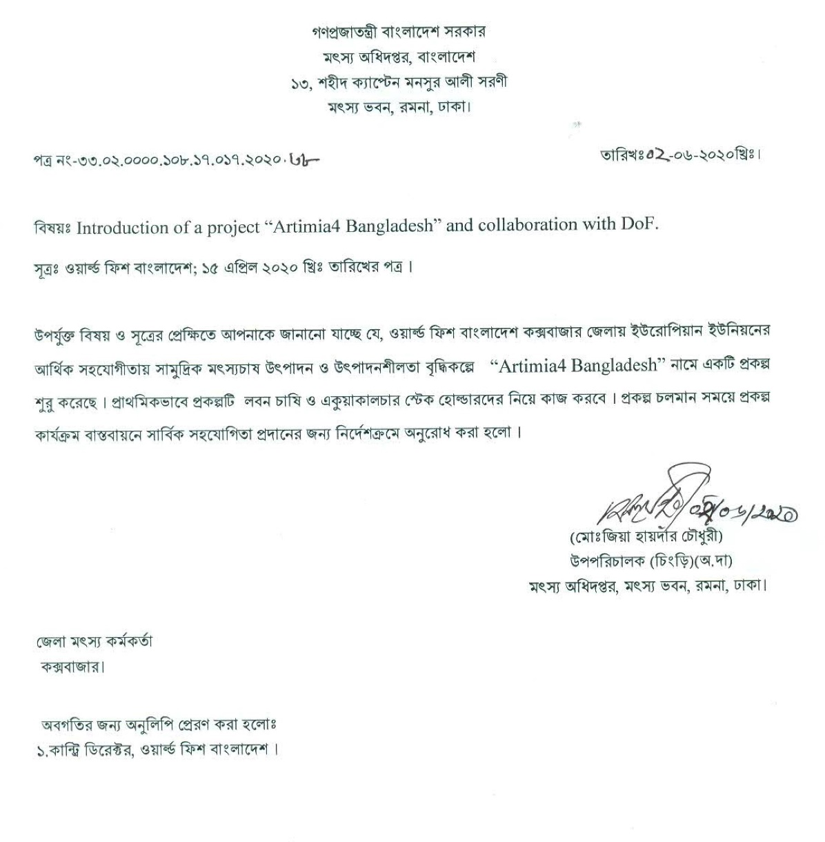

Annex 7: BFRI letter to collaborate with Artemia4Bangladesh
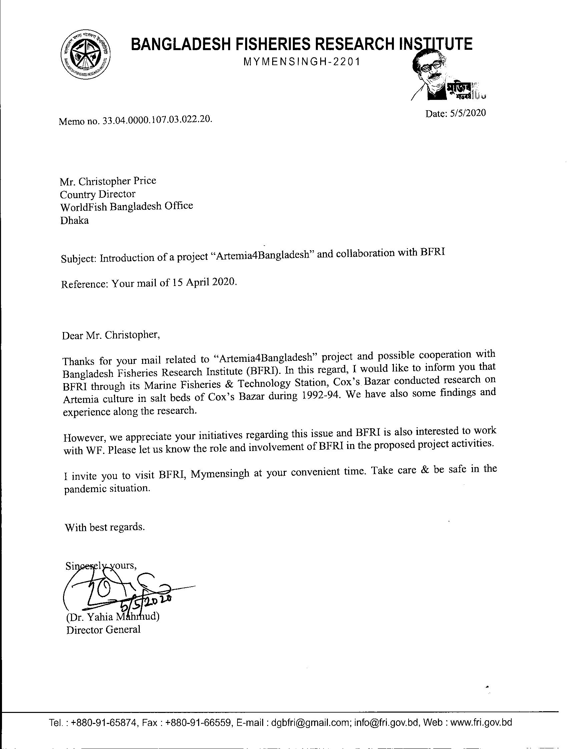

Annex 8: Fisheries resource information of Cox’s Bazar district (Bangla version)
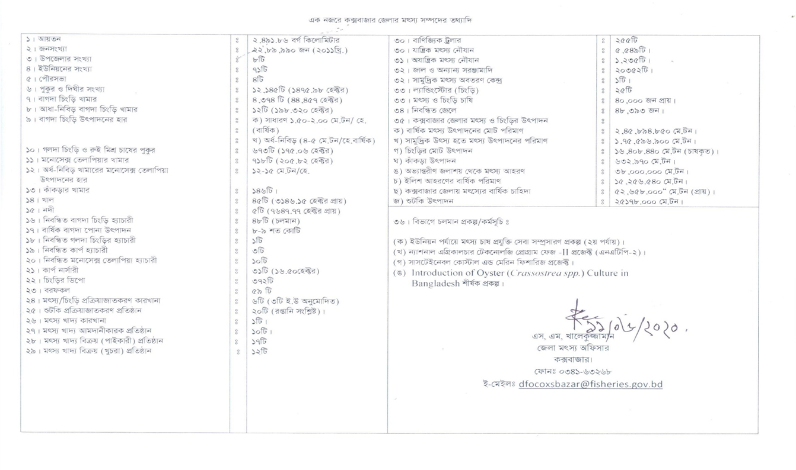

Annex 9: Fisheries resource information of Cox’s Bazar district (English version)
01. Area  02. Population  03. Upazila  04. Union  05. Pourashova  06. Ponds  07. Shrimp farm  08. Semi-intensive shrimp farm  09. Shrimp production rate  10. Freshwater prawn and Rui polyculture  11. Monosex tilapia farm  12. Semi-intensive monosex tilapia production rate  13. Crab farm  14. Canals  15. Rivers  16. Registered shrimp hatchery in operation  17. Annual shrimp post larvae production  18. Registered prawn hatchery  19. Registered carp hatchery  20. Registered monosex tilapia hatchery  21. Carp nursery  22. Shrimp depots  23. Ice factories  24. Fish/ shrimp processing factory  25. Dry fish processing  26. Fish feed factory  27. Fish feed importer  28. Fish feed whole seller  29. Fish feed retailer  30. Commercial trawler | 249,186 square kilometer  2,289,990 (2011 census)  08  71  04  12145 (1475.98 ha)  4374 (44,457 ha)  12 (198.320 ha)  General: 1.5-2.0 MT/ha/year  Semi intensive 4-5 MT/ ha/year  673 (175 ha)  718 (205.8 ha)  12-15 MT/ ha  146  45 (3146.2 ha)  05 (7647.8 ha)  48  8-9 billion  01  03  10  31 (16.50 ha)  372  59  6 (3 EU approved)  20 (export)  01  01  17  12  255 | 31. Mechanized boat  32. Artisanal boat  33. Net and gears  34. Fish landing centre  35. Landing store (shrimp)  36. Fish/ shrimp farmer  37. Registered fishermen  38. Total shrimp/fish production in Cox’s Bazar  (a) Total fish production  (b) Marine fisheries production  (c) Total shrimp production (culture)  (d) Crab production  (e) Inland capture fisheries  (f) Annual Hilsa production  (g) Demand of fish in Cox’s Bazar  (h) Dry fish production  39. Ongoing projects  (a) Fish culture extension at union level (2nd phase)  (b) National Agriculture Technology Program - Phase II (NATP)  (c) Introduction of oyster (Crassostrea sp.) culture in Bangladesh  (Signed) Dated 11 June 2020  Mr. S.M. Khalequzzaman  DFO, Cox’s Bazar  Cox’s Bazar | 5549  1235  20352  01  25  40,000  48,393  245894.85 MT  175,596.9 MT  16408.4 MT  632.9 MT  38,000 MT  15,256.5 MT  52,658.0 MT  25,178.0 MT
Annex 10: Revised work plan for the period of July to December 2020

Workplan | Year 1
Workplan | Q1 |  |  | Q2 |  |  | Q3 |  |  | Q4
Workplan | Jan | Feb | Mar | Apr | May | Jun | Jul | Aug | Sep | Oct | Nov | Dec
General activities
(i) Project inception, progress evaluation meeting (Virtually) |  |  |  |  |  |  |  |  |  | x |  | x
(ii) Local office set up in Coxsbazar |  |  |  |  |  |  |  | x | x | x
(iii) Recruitment of project staffs |  |  |  |  |  |  |  | x | x
(iv) Stakeholder consultation meeting/ training |  |  |  |  |  |  |  |  | x | x | x | x
(v) Partnership and collaboration with national (DoF, BFRI, Universities, BATiP, hatchery association, farmer association ) and international organizations (Ghent University, CanTho University, Thai Department of Fisheries) |  |  | x | x | x | x | x | x | x | x | x | x
(vi) Training and extension material development (audio visual, poster, leaflets, mobile apps, TV documentary, newspaper articles, social campaign) |  |  | x | x | x | x | x | x | x | x | x | x
(vii) Communication and visibility material development |  |  |  |  |  | x | x | x | x | x | x | x
(vii) Baseline survey |  |  |  |  |  |  |  | x | x | x | x | x
(ix) Identify climate sensitive management decisions for managing climate induced risks in aquaculture |  |  |  |  |  |  |  | x | x | x
(x) Research in collaboration with European, SE Asian and Bangladeshi Universities (M.Sc and Ph.D. studies) |  |  |  |  |  |  | x | x | x | x | x | x
(xi) Annual Regional Artemia workshop on production and use in seasonal salt pond systems in Asia: exchange of findings, identification of common problems, inter calibration of quality control, opportunities for exchange and cooperation (ongoing projects/interests in Vietnam, Thailand, Myanmar, Cambodia, Laos, Indonesia, Philippines, Malaysia), new product applications |  |  |  |  |  |  |  |  |  |  | x | x
ER 1.1 : Artemia cyst and salt integrated production system proven feasible
(i) Identify opinion leaders and entrepreneurs among salt farmers as entry points. |  |  | x | x | x
(ii) Identification and selection of appropriate sites for demonstration farms in close coordination with the salt farmers |  |  |  |  |  |  |  |  |  | x | x
(iii) Set up demonstration farms |  |  |  |  |  |  |  |  |  | x | x | x
(iv) Capacity building Training of Trainers (ToT) for the main stakeholders and project staff on Artemia biology and use in aquaculture, pond production of Artemia cyst and biomass, and Artemia cyst processing and packaging |  |  |  |  |  |  |  |  |  | x
(v) Set up one Artemia laboratory for quality control and for production of inoculation material |  |  | x | x | x | x | x | x | x | x | x | x
(vi) Set up facility for Artemia cyst and biomass processing and packaging |  |  |  | x | x | x | x | x | x | x | x | x
ER 1.2 Artemia cyst and salt integrated production system effectively established and widespread among the salt farmers.
(i) Technical assistance for scaling of Artemia cyst and biomass production through training of extension agents, local service providers, organize visits |  |  |  |  |  |  |  | x | x | x | x | x
(ii) Compare the performance of Artemia cyst and biomass in hatcheries, nurseries and in maturation (in comparison with present protocols) |  |  |  |  |  |  |  |  |  |  |  | x
(iii) Facilitate/ collaboration with financial/ microcredit institutions for access to credit for Artemia cyst and biomass production |  |  |  |  |  |  |  |  |  |  |  | x
ER 2.1 Marine aquaculture productivity and production increased due to low cost locally produced Artemia cyst.
(iii) Evaluate potential (technical and economical) for the production of brine in existing salt farms and in new areas (Khulna, Sathkira) for use in local shrimp/prawn hatcheries as an (even better) alternative for (hauled in) seawater |  |  |  |  |  |  |  |  |  | x | x | x
(iv) Study to determine maximum acceptable brine salinity for use in shrimp, prawn and marine fish hatcheries (apparently higher in Macrobrachium hatcheries than the maximum of 120 g/L for Penaeid shrimp and marine fish) |  |  |  |  |  |  |  |  |  |  | x | x
(vi) Exchange visit, group discussion, share findings to promote brine usage in shrimp/ prawn hatcheries (next year)
ER 2.2 Increased revenue of salt farmers due to adoption of a second profitable activity (aquaculture).
(i) International training on shrimp nursery, integrated pond production of shrimp, Marine fish, crab and Tilapia |  |  |  |  |  |  |  |  |  |  | x | x
(ii) Set up demonstration of good aquaculture practice to improve shrimp/ fish / crab production at nursery, grow out and maturation stage (next year)
(iii) Training and extension on good aquaculture practice (next year)
(iv) Set up nursery to improve quality of shrimp PL and increased availability (next year)
(v) Facilitate/ collaboration with financial/ microcredit institutions for access to credit for integration with aquaculture |  |  |  |  |  |  |  |  |  | x | x | x
ER 2.3 Enhanced saline tolerant species seed production due to adoption of improved technologies
(i) International training on Recirculation technique for shrimp hatcheries,
crablet and marine fish fry production (next year)
(ii) Establish and support a network with hatcheries to supply pathogen free and high quality shrimp PL/ fish fry |  |  |  |  | x | x | x | x
(iii) Evaluate the support of hatcheries for crablet production |  |  |  |  |  | x | x | x | x
(iv) Evaluate and support the hatcheries for marine fish fry (eg. sea bass) production |  |  |  |  |  | x | x

Annex 11: Collaboration with DoF to set up Artemia Laboratory

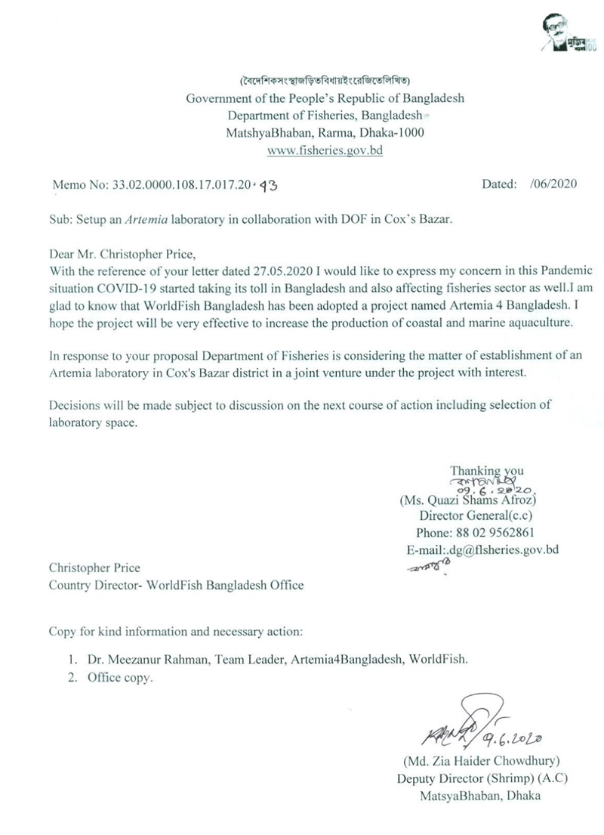

Annex 12: Salt production report Cox’s Bazar (Bangla version)
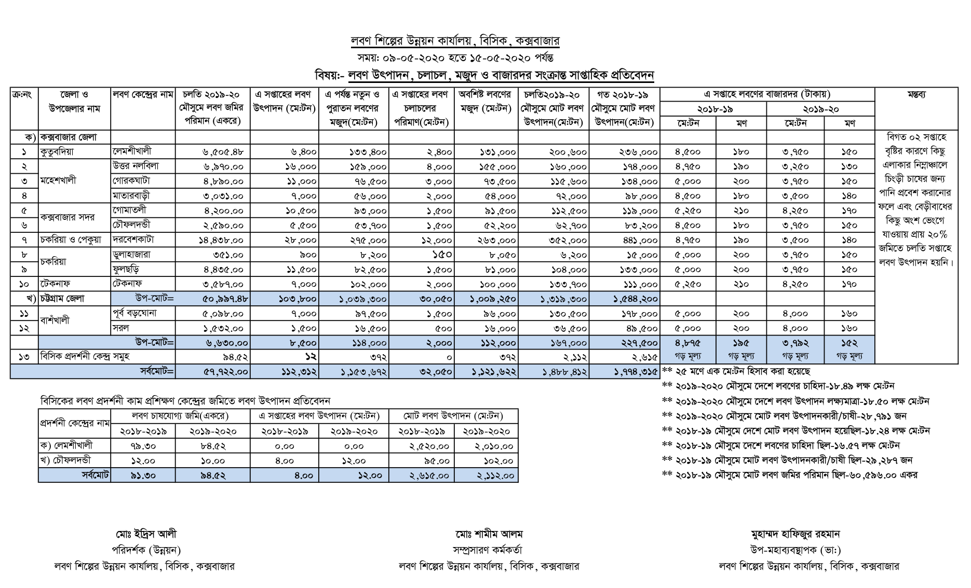

Annex 13: Salt production report Cox’s Bazar (English version)

Annex 14: Opinion leaders in Cox’s Bazar district
Serial number | Name and Designation | Address | Mobile | Email
1 | Mr. Zia Haider Chowdhury, Deputy Director (Shrimp), DoF | DoF, Dhaka | +8801711466152 | zhc_farid67@yahoo.com;  ddshrimp@fisheries.gov.bd
2 | Mr. S.M Khalequzzaman, District Fisheries Officer, DoF, Cox’s Bazar | DoF, Cox’s Bazar | +8801779572887 | biplabku1974@gmail.com
3 | Mr. Hafizur Rahman, Deputy General Manager, BSCIC | BSCIC, Cox’s Bazar | +8801717625781 | saltbsciccoxsbazar@yahoo.com;  mhafiz1982@gmail.com
4 | Dr. Shafiqur Rahman, Chief Scientific Officer, BFRI, Cox’s Bazar | BFRI, Cox’s Bazar | +8801730302661 | shafiqbfri@yahoo.com
5 | Mr. Asheq Ullah Rafiq, MP, President, Shrimp Hatchery Association of Bangladesh (SHAB) | Cox’s Bazar | +8801711979038
6 | Mr. Najibul Islam, Secretary, SHAB | Cox’s Bazar | +8801819345775
7 | Mr. Barequl Islam Chowdhury, Assistant Director-Enterprise Development,  Coast Trust | www.coastbd.net  Cox’s Bazar | +8801713328811 | barek@coastbd.net  Skype: barek.coast
8 | Mr. S. Shahid, Director, Program Prottyashi | www.prottyashi.org | +8801713212212 | prottyashi.ctg@gmail.com
9 | Mr. Satchidananda Biswas, Deputy Director (Programme) & Head of Disaster Management Cell, Shushilan | www.shushilan.org Teknaf, Cox’s Bazar | +88 01712334808 | sbiswas@shushilan.org; sbiswas_77@yahoo.com
10 | Mr. Sajedul Karim, President, Labon Chasi Samity | Chokoria, Cox’s Bazar | +8801720590730 | Sazedulkarim03@gmail.com
11 | Mr. Ahsanul Karim, Secretary, Labon Chasi Samity | Chokoria, Cox’s Bazar | +8801823911031 | ahsanulkarim1988@gmail.com
12 | Mr. Shahidul Alam Chowdhury, Golden Aquaculture Shrimp hatchery | Cox’s Bazar | +8801819386073 | sha_ctg.shahid@yahoo.com
13 | Mr. Mison Datta, Modern hatchery Limited | Cox’s Bazar | +8801741653432; +8801714080693 | mison@bsmgroupbd.com
14 | Mr. Tarique Sarker, Managing Director, Fish Tech (BD) Limited | Dhaka | +8801926990500 | tarique_fc@yahoo.com
15 | Mr. Aung Sein, Director, Irwan trading (crab hatchery and exporter) | Cox’s Bazar | +880171171188 | harbourcx12@gmail.com
16 | Mr. Raisuddin, Senior General Manager, Spectra Hexa Mega Feed Limited | Cox’s Bazar | +8801715033967 | raisspl@yahoo.com

